1. The difference betweem Gouraud shading and Phong shading is that Gouraud shading works by approximating the normal to the surface at the vertex by averaging all normal and calculating the intensity at each vertex using the illumination equations. It also uses linear interpolation. This can be seen below:

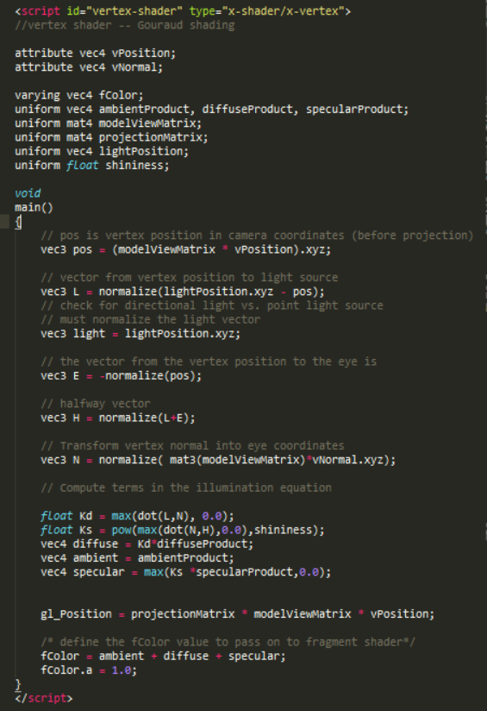

Phong shading on the other hand highlights shiny objects by approximation of the normal vector at each pixel. It uses an algorithm to calculate the normal at each vertex of a polygon and then interpolates the normal vectors for each point inside the polygon. This can be seen below: 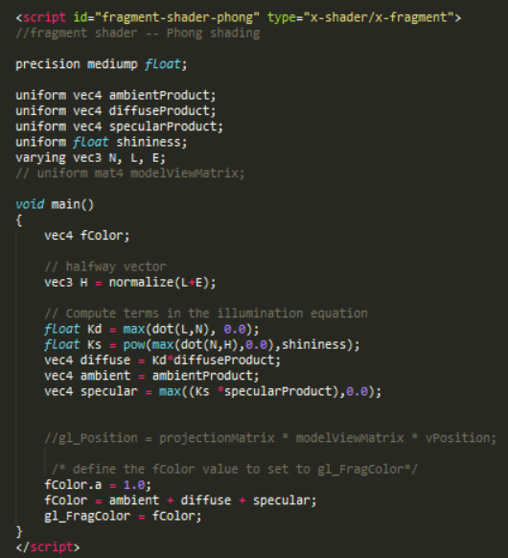

1. The non-physical assumptions are that there is point light source or an infinity light source and that there is only one reflection. These are assumptions are made because there has to be a source in where the light comes from and it is hard to reproduce more than one reflection.